Functional
Specification

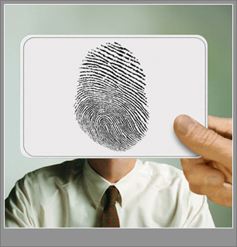

Student Name: Wen Liu
ID Number: C00105088
Project: Fingerprint Recognition
Supervisor: Nigel Whyte (M.Sc. MIEEE)
Date: 07/12/2009

Contents

- Introduction ……………………………………………….. 2

- Functionality of application …………………………………… 2

2.1 Core Functionality ……………………………………….. 2
2.2 Less important Functionality ………………….………... 3

- Potential user of application …………………………........... 4

- Metrics ……………………………………………………….. 5

- Similar application in existence and differences …………….. 6

6. Conclusions ……………………………………………….. 10

- Introduction
Biometric recognition, or simply biometrics, refers to the use of distinctive anatomical and behavioral characteristics or identifiers (e.g., fingerprints, face, iris, voice, hand geometry) for automatically recognizing a person.
This project – FingerprintSpy, is an easy to use fingerprint recognition application based on biometric identification technology, which can help user to match a fingerprint image with another for verification, identification and output the matching result. The application will be a Windows based software with a friendly GUI (Graphic User Interface).

- Functionality of Application

2.1 Core Functionality
- Fingerprint Recognition :
The most important function of this application is fingerprint recognition. The recognition function works based on enrolled fingerprints with minutiae extracted. User selects two enrolled fingerprint images from processed image database and the system will then output the result with a comments.

- Fingerprint Enrollment :
The fingerprint enrollment is the image preprocess phase of the application. In this process, the fingerprint image will be processed with several sub-functions:
  - Image enhancement: use edge detection technique to highlight ridges from valleys and background.
  - Image thinning: thin the enhanced image with image skeletonization technique.
  - Minutiae extraction: extract minutiae of processed image.
  - False minutiae elimination: remove all false minutiae from processed image.
The final product of this process is a fingerprint image with all its minutiae represent on the image and all false minutiae were removed. This fingerprint image will then be saved into system database for matching use.

2.2 Less Important Functionality
- Printing Fingerprint Image :
The processed fingerprint image can be printed out for further use. The image is the final product of fingerprint enrollment process.
- Fingerprint Database Management :
User can manage (rename, delete enrolled fingerprint images or rewrite their comments) the image database.
- Printing Matching Result :
The matching result of two fingerprints and their selves can be printed out as well. A print preview is also available.
- Help Document :
There is a help tips document of the application to help user to manipulate the software.

- Potential User of Application
As a biometric recognition application, FingerprintSpy provides a good balance of security, privacy, convenience and accountability. Because the limit of my knowledge, the application may is not suit for criminal investigations or law enforcement. The potential user of the application may from the following commercial or study sections:
- Social Security
- Electronic Data Security
- E-Commerce
- ATM, Credit Card identity validation
- Personal Digital Assistant
- Medical Records Management
- Distance Learning
- Image preprocessing study

- Metrics
A successful fingerprint recognition application should be able to process fingerprint image as enhancing image, running edge detection on the image, thinning image, extracting minutiae of fingerprint and, the most important, to matching two fingerprints and output the matching result. Managing a well designed fingerprint database with a proper scheme is also an important achievement. The accuracy of the matching result and reliability of the system is another emphasis measurement of achievement of a fingerprint recognition application.
I am grand if FingerprintSpy can achieve the functionalities I mentioned above with acceptable matching result accuracy and system reliability.

- Similar Application In Existence and Differences
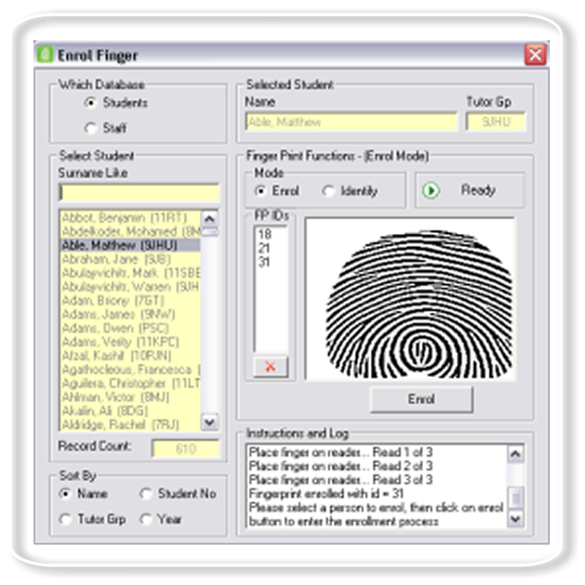
During high level research period, I tried several existent fingerprint recognition applications. Most of them are commercial application and contains high accuracy of matching result. However, there are many buttons and options in those applications that make manipulation very difficult.
From above figure, we can see the layout of GUI is very complex. It confuses the user who does not familiar with fingerprint recognition applications.
Figure 1 A screenshot of the GUI of a fingerprint recognition application - TouchRegistration.
As I mentioned already, the fingerprint image pre-processing is also a very important measurement. But most those application could not show the result after each image pre-processing step – the final result be showed directly.
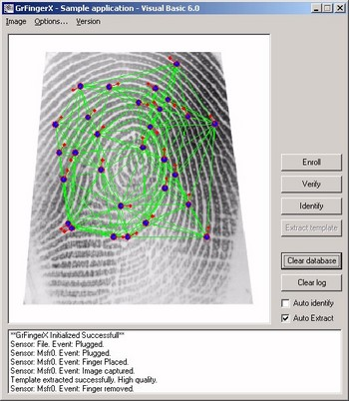
Figure 2 A screenshot of GrFingerX, which shows the matching result straightly after user input two original fingerprint images.
The final product of my project – FingerprintSpy, is an easy to use application and it is able to show the products of each image pre-processing stage. It helps those users who studying on the image processing topic to realise the effect of each image pre-processing step.
The figure 3 below shows the screenshot of application’s GUI from fingerprint enrolment section.
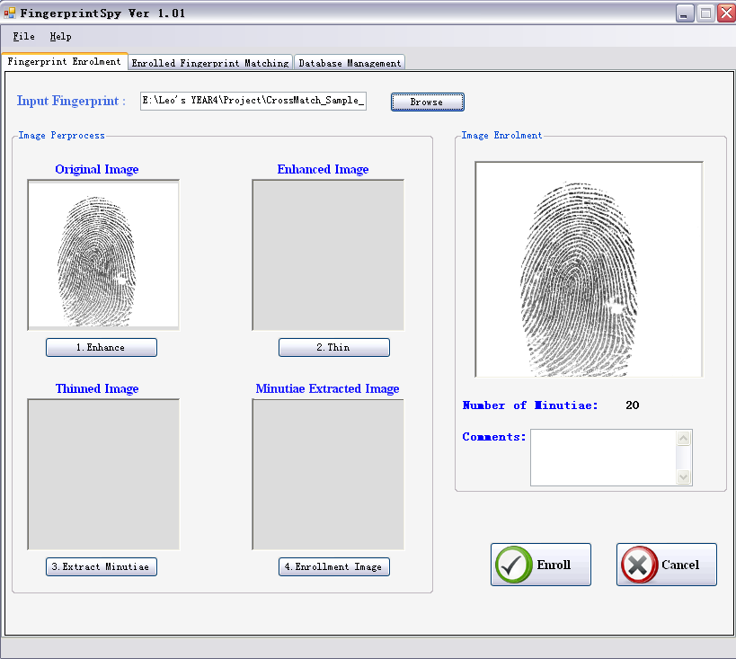
Figure 3 A screenshot of project fingerprint enrolment GUI
In FingerprintSpy, after user click those buttons in “Image pre-processing” group in sequence, the product of corresponding process will be showed in those picture boxes. The final product of this stage is showed in the picture box on the right. User can easy to find out the difference of the image after each step.
The matching function of the application is also very straight forward, as showed in the figure below.
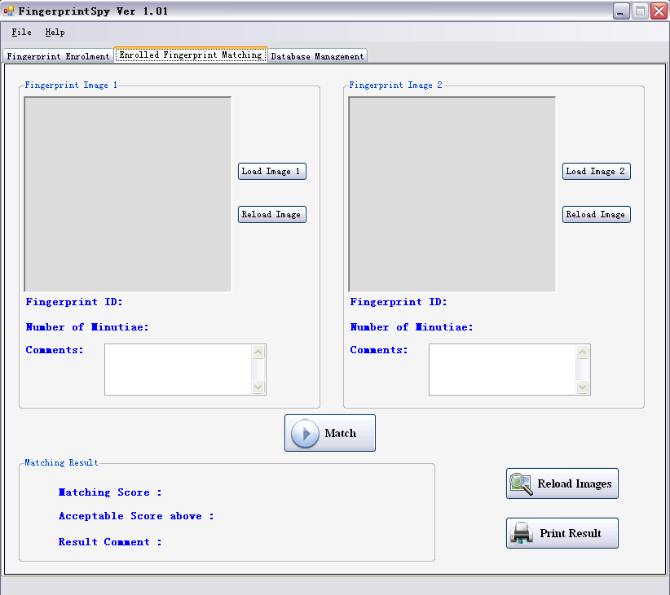
Figure 4 A screenshot of application of matching section
Does not likes those applications I used, to do fingerprint matching, user only need to load two enrolled fingerprint images from system database and click the “Match” button – no other selection or parameter input required. The result will be showed in “Matching Result” area at the bottom. Matching result - will not like other applications only a matching score or a level of similarity. The matching result of FingerprintSpy will be an integration. It contains a matching score, a suitable threshold value of matching, and comments based on those two values above. It will give a more reasonable vision of fingerprint matching result.
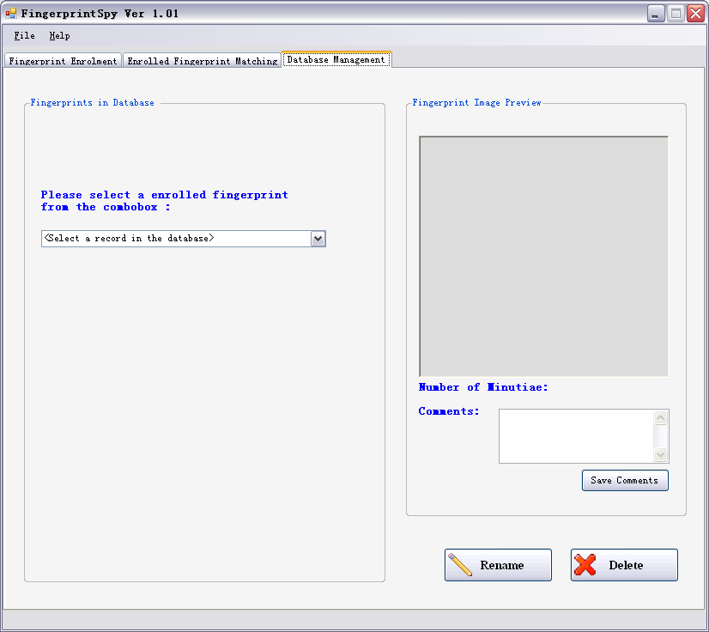
The FingerprintSpy application also has a visual database management interface which other fingerprint recognition applications don’t have. (see figure5.) User can select a enrolled image and rename it, change its comments, or delete this image. An image preview is available for convenience.
Figure 5 A screenshot of database management function of FingerprintSpy
With these features, the FingerprintSpy will be the most friendly fingerprint recognition software I ever meet.

- Conclusion
In this paper, I mentioned main functionality of the product of my project and its potential user. I also mentioned the metrics of a successful fingerprint application and the expectance of my application. Last but not least, the difference between my application (except technique differences) and those applications I used are also described.

